time series foreCAsting

Table of Contents

[1. Forecasting 1](#_Toc420594689)

[1.1. Why is forecasting important? 1](#_Toc420594690)

[1.2. Types of Forecasting 2](#_Toc420594691)

[1.2.1. Qualitative forecasting: 2](#_Toc420594692)

[1.2.2. Quantitative forecasting: 2](#_Toc420594693)

[2. Definition of Time Series Forecasting 3](#_Toc420594694)

[3. Three Types of Time Series Forecast: 4](#_Toc420594695)

[4. Components of a Time Series Data 5](#_Toc420594696)

[4.1. Trend component: 6](#_Toc420594697)

[4.2. Cyclical component**:** 7](#_Toc420594698)

[4.3. Seasonal component: 8](#_Toc420594699)

[4.4. Irregular component 9](#_Toc420594700)

[5. How do I know which decomposition model to use? 10](#_Toc420594701)

[6. Measuring Accuracy 11](#_Toc420594702)

[7. Smoothing Time Series : 13](#_Toc420594703)

[How to compare several smoothing methods: 13](#_Toc420594704)

[7.1 Moving Average : 14](#_Toc420594705)

[7.2 Weighted Moving Average: 17](#_Toc420594706)

[7.3 Double moving average: 19](#_Toc420594707)

[7.4 Exponent Smoothing: 20](#_Toc420594708)

[7.5 Double Exponent Smoothing 22](#_Toc420594709)

[8 Trend Models 23](#_Toc420594710)

[9 Seasonal effects 27](#_Toc420594711)

[9.1 Additive Seasonal Model 28](#_Toc420594712)

[9.2 Multiplicative Seasonal Model: 30](#_Toc420594713)

[10 HOLTS WINTERS Model 31](#_Toc420594714)

[10.1 Holt-Winters additive method 32](#_Toc420594715)

[10.2 Holt-Winters multiplicative method 33](#_Toc420594716)

# Forecasting

Forecasting is the process of making predictions of the future based on past and present data and analysis of trends. A common example may be [estimation](http://en.wikipedia.org/wiki/Approximation) of some variable ( like annual rainfall or weather forecasting, market demand of any product. life expectancy etc) at some specified future date.

[Prediction](http://en.wikipedia.org/wiki/Prediction) is a similar, but more general term, both might refer to formal statistical methods employing [time series](http://en.wikipedia.org/wiki/Time_series), [cross-sectional](http://en.wikipedia.org/wiki/Cross-sectional_data) or [longitudinal](http://en.wikipedia.org/wiki/Longitudinal_study) data, or alternatively to less formal judgmental methods.

Usage can differ between areas of application: for example, in [hydrology](http://en.wikipedia.org/wiki/Hydrology)( scientific study of the movement, distribution, and quality of water on Earth) the terms "forecast" and "forecasting" are sometimes reserved for estimates of values at certain specific [future](http://en.wikipedia.org/wiki/Future) times, while the term "prediction" is used for more general estimates, such as the number of times floods will occur over a long period.

[Risk](http://en.wikipedia.org/wiki/Risk) and [uncertainty](http://en.wikipedia.org/wiki/Uncertainty) are central to forecasting and prediction; it is generally considered good practice to indicate the degree of uncertainty attaching to forecasts. In any case, the data must be up to date in order for the forecast to be as accurate as possible.

.

## Why is forecasting important?

Forecasting of natural calamity like draught, flooding, epidemic( like dengue) in a state / country well in advance allows the Govt./ Planner/Agencies to take the measures to minimize the impact in form of loss of life , property.

Forecasting is of utmost importance in setting up a new business or running a business . It is not an easy task to start a new business as it is full of uncertainties and risks. With the help of forecasting the entrepreneurs can find out whether he can succeed in the business; whether he can face the existing competition; what is the possibility of creating demand for the proposed product etc. Forecasting can be used for…

* Strategic planning (long range planning)
* Finance and accounting (budgets and cost controls)
* Marketing (future sales, new products)
* Production and operations

## Types of Forecasting

## Qualitative forecasting:

These techniques are subjective , based on the opinion and judgment of consumers ,experts: appropriate when past data is not available. It is usually applied to intermediate-long range decisions.

## Quantitative forecasting:

They are used to estimate future demands as a function of past data; appropriate when past data is available. It is usually applied to short-intermediate decisions.

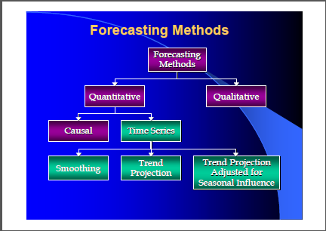

# Definition of Time Series Forecasting

A time series is a sequence of observations on a variable measured at successive points in time or over successive periods of time. The measurements may be taken every hour, day, week, month, or year, or at any other regular interval.1 The pattern of the data is an important factor in understanding how the time series has behaved in the past. If such behavior can be expected to continue in the future, we can use the past pattern to guide us in selecting an appropriate forecasting method.

Time series are any univariate or multivariate quantitative data collected over time either by private or government agencies. Common uses of time series data include:

* Modeling the relationships between various time series;
* Forecasting the underlying behavior of the data
* Forecasting what effect changes in one variable may have on the future behavior of another variable.

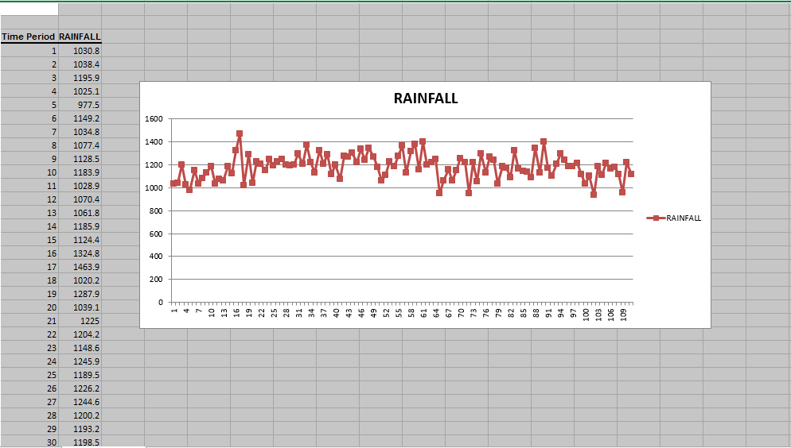

# Three Types of Time Series Forecast:

* **Point Forecast** : a single number or a "best guess." It does not provide information on the level of uncertainty around the point estimate/forecast. For example, an economist may forecast a 10.5% growth in unemployment over the next six months.
* **Interval Forecast**: relative to a point forecast, this is a range of forecasted values which is expected to include the actual observed value with some probability. For example, an economist may forecast growth in unemployment rate to be in the interval, 8.5% to 12.5%. An interval forecast is related to the concept of confidence intervals.
* **Density Forecast**: this type of forecast provides information on the overall probability distribution of the future values of the time series of interest. For example, the density forecast of future unemployment rate growth might be normally distributed with a mean of 8.3% and a standard deviation of 1.5%.

Relative to the point forecast, both the density and the interval forecasts provide more information since we provide more than a single estimate, and we provide a probability context for the estimate. However, despite the importance and more comprehensive information contained in density and interval forecasts, they are rarely used by businesses. Rather, the point forecast is the most commonly used type of forecast by businesses managers and policymakers.

# Components of a Time Series Data

Any time series can contain some or all of the following components:

1. Trend (T)
2. Cyclical (C)
3. Seasonal (S)
4. Irregular (I)

These components may be combined in different ways. It is usually assumed that they are multiplied or added, i.e.,

yt = T × C × S × I

yt = T + C + S + I

To correct for the trend in the first case one divides the first expression by the trend (T). In the second case it is subtracted.

# Trend component:

Although time series data generally exhibit random fluctuations, a time series may also show gradual shifts or movements to relatively higher or lower values over a longer period of time. If a time series plot exhibits this type of behavior, we say that a trend pattern exists. A trend is usually the result of long-term factors such as population increases or decreases, changing demographic characteristics of the population, technology, and/or consumer preferences.

Trend is a long-term movement in a time series. It is the underlying direction (an upward or downward tendency) and rate of change in a time series. A simple way of detecting trend in seasonal data is to take averages over a certain period. If these averages change with time, we can say that there is an evidence of a trend in the series. There are no proven "automatic" techniques to identify trend components in the time series data; however, as long as the trend is monotonous (consistently increasing or decreasing) that part of data analysis is typically not very difficult. If the time series data contain considerable error, then the first step in the process of trend identification is smoothing.

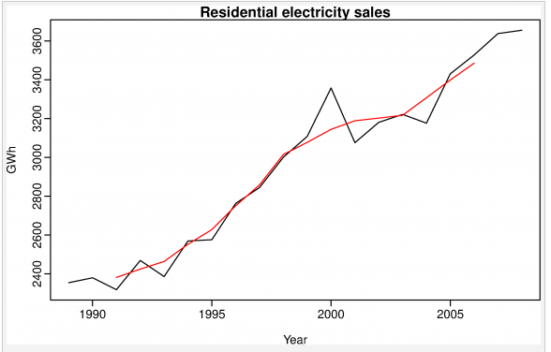

Residential electricity sales (black) along with the 5-MA estimate of the trend-cycle (red).

# Cyclical component:

Any pattern showing an up and down movement around a given trend is identified as a cyclical pattern. The duration of a cycle depends on the type of business or industry being analyzed.

A cyclic pat­tern exists when data exhibit rises and falls that are not of fixed period. The dura­tion of these fluc­tu­a­tions is usu­ally of at least 2 years. Think of busi­ness cycles which usu­ally last sev­eral years, but where the length of the cur­rent cycle is unknown beforehand.

Many peo­ple con­fuse cyclic behav­iour with sea­sonal behav­iour, but they are really quite dif­fer­ent. If the fluc­tu­a­tions are not of fixed period then they are cyclic; if the period is unchang­ing and asso­ci­ated with some aspect of the cal­en­dar, then the pat­tern is sea­sonal. In gen­eral, the aver­age length of cycles is longer than the length of a sea­sonal pat­tern, and the mag­ni­tude of cycles tends to be more vari­able than the mag­ni­tude of sea­sonal patterns.

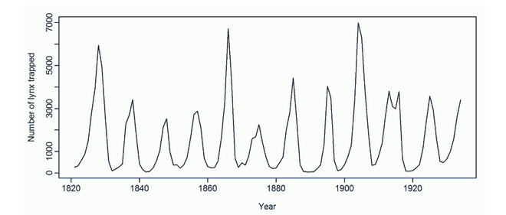

The top plot shows the famous Cana­dian lynx data — the num­ber of lynx trapped each year in the McKen­zie river dis­trict of north­west Canada (1821−1934). These show clear ape­ri­odic pop­u­la­tion cycles of approx­i­mately 10 years. The cycles are not of fixed length — some last 8 or 9 years and oth­ers last longer than 10 years.

# Seasonal component:

Seasonality occurs when the time series exhibits regular fluctuations during the same month (or months) every year, or during the same quarter every year. Seasonal patterns are recognized by seeing the same repeating patterns over successive periods of time. For instance, retail sales peak during the month of December. A sea­sonal pat­tern exists when a series is influ­enced by sea­sonal fac­tors (e.g., the quar­ter of the year, the month, or day of the week). Sea­son­al­ity is always of a fixed and known period. Hence, sea­sonal time series are some­times called peri­odic time series.

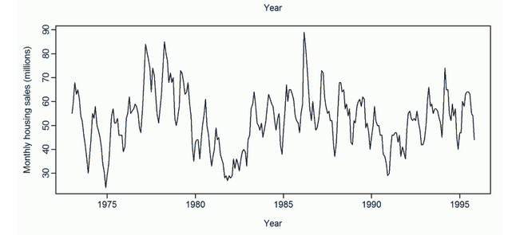

The plot shows the monthly sales of new one-​​family houses sold in the USA(1973−1995). There is strong sea­son­al­ity within each year, as well as some strong cyclic behav­iour with period about 6 – 10 years.

# Irregular component

They correspond to the movements that appear irregularly and generally during short periods.

Irregular variations do not follow a particular model and are not predictable.

Every time series has some unpredictable component that makes it a random variable. In prediction, the objective is to “model” all the components to the point that the only component that remains unexplained is the random component.

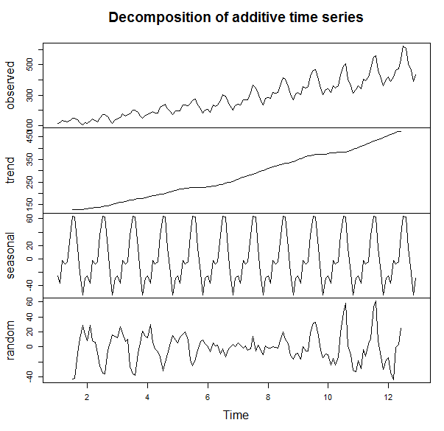

# How do I know which decomposition model to use?

There are many, many different time series techniques.It is usually impossible to know which technique will be best for a particular data set.It is customary to try out several different techniques and select the one that seems to work best.To be an effective time series modeler, you need to keep several time series techniques in your “tool box.”To choose an appropriate decomposition model, the time series analyst will examine a graph of the original series and try a range of models, selecting the one which yields the most stable seasonal component

* The additive model is useful when the seasonal variation is relatively constant over time. If the magnitude of the seasonal component is relatively constant regardless of changes in the trend, an additive model is suitable.
* The multiplicative model is useful when the seasonal variation increases over time. If the magnitude of the seasonal component varies with changes in the trend, a multiplicative model is the most likely candidate.

# Measuring Accuracy

We need a way to compare different time series techniques for a given data set. Four common techniques are the:

Mean absolute deviation,

Mean absolute percent error,

Mean square error,

Root mean square error.

Running sum of forecasting errors

Tracking signal





## 6.1 MSE(MEAN SQUARED ERROR)

If \hat{Y} is a vector of n predictions, and Y is the vector of the true values, then the (estimated) MSE of the predictor is:

\operatorname{MSE}=\frac{1}{n}\sum_{i=1}^n(\hat{Y_i} - Y_i)^2.

This is a known, computed quantity given a particular sample (and hence is sample-dependent).

The Mean Squared Error (MSE) is a measure of how close a fitted line is to data points. For every data point, you take the distance vertically from the point to the corresponding y value on the curve fit (the error), and square the value. Then you add up all those values for all data points, and divide by the number of points minus two.\*\* The squaring is done so negative values do not cancel positive values. The smaller the Mean Squared Error, the closer the fit is to the data. The MSE has the units squared of whatever is plotted on the vertical axis. An MSE of zero, meaning that the estimator \hat{\theta} predicts observations of the parameter \theta with perfect accuracy, is the ideal, but is practically never possible.Values of MSE may be used for comparative purposes. Two or more [statistical models](http://en.wikipedia.org/wiki/Statistical_model) may be compared using their MSEs as a measure of how well they explain a given set of observations

## 6.2 MAD(MEAN ABSOLUTE DEVIATION)

|  |
| --- |
| The mean deviation is the first measure of dispersion. It is the average of absolute differences between each value in a set of value, and the average of all the values of that set.The Mean Absolute Deviation (MAD) of a set of data is the average distance between each data value and the mean. The mean absolute deviation is the "average" of the "positive distances" of each point from the forecast .   Keep in mind that judging the dependability of forecasts isn’t always about minimizing MAD. MAD, after all, is an average of deviations. |
|  |

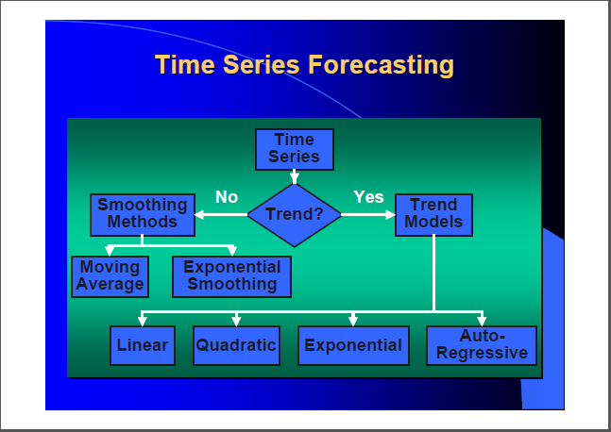

# Smoothing Time Series :

Smoothing is usually done to help us better see patterns, trends for example, in time series.  Generally smooth out the irregular roughness to see a clearer signal.  For seasonal data, we might smooth out the seasonality so that we can identify the trend.  Smoothing doesn’t provide us with a model, but it can be a good first step in describing various components of the series. The term **filter** is sometimes used to describe a smoothing procedure.  For instance, if the smoothed value for a particular time is calculated as a linear combination of observations for surrounding times, it might be said that we’ve applied a linear filter to the data (not the same as saying the result is a straight line, by the way).

How to compare several smoothing methods:

Although there are numerical indicators for assessing the accuracy of the forecasting technique, the most widely approach is in using visual comparison of several forecasts to assess their accuracy and choose among the various forecasting methods. In this approach, one must plot (using, e.g., Excel) on the same graph the original values of a time series variable and the predicted values from several different forecasting methods, thus facilitating a visual comparison

# 7.1 Moving Average

The moving averages method consists of computing an average of the most recent n data values for the series and using this average for forecasting the value of the time series for the next period. (most recent data values).

Moving Average =

* No general method exists for determining *k.*To take away seasonality from a series, so we can better see trend, we would use a moving average with a length = seasonal span.
* We must try out several *k* values to see what works best.
* There are several moving average models that can be used in contract pricing. The two most commonly used are the single moving average and the double moving average.
* Your decision on which model to use will depend on whether the data indicate a trend (upward or downward) in the values of the dependent variable.
* If there is:
* No time-series data trend - use a single moving average.
* Time-series data trend - use a double moving average.

**EXCEL**

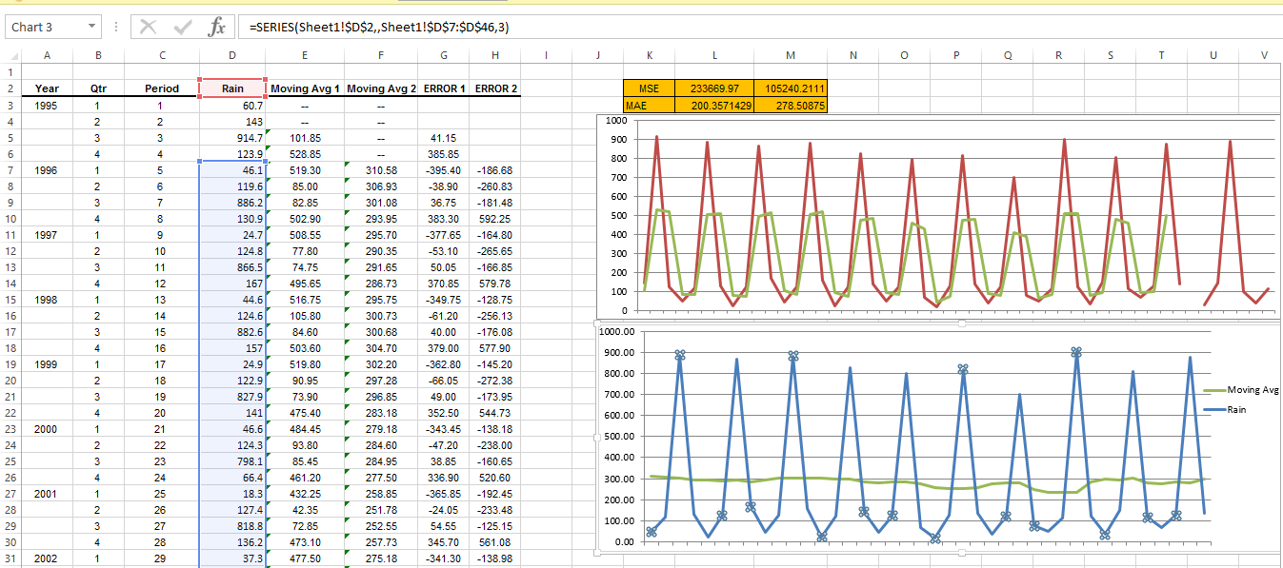

**ZIATUN**

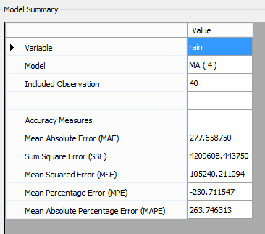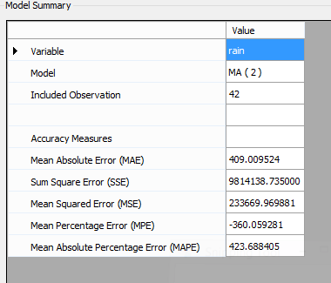

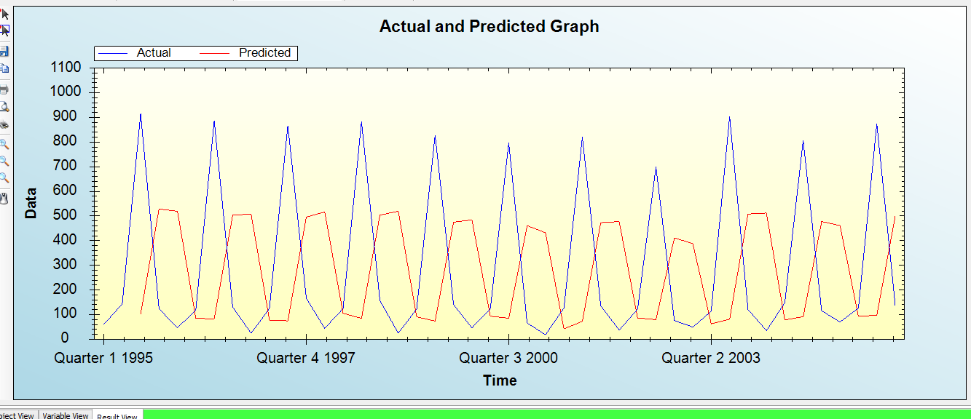

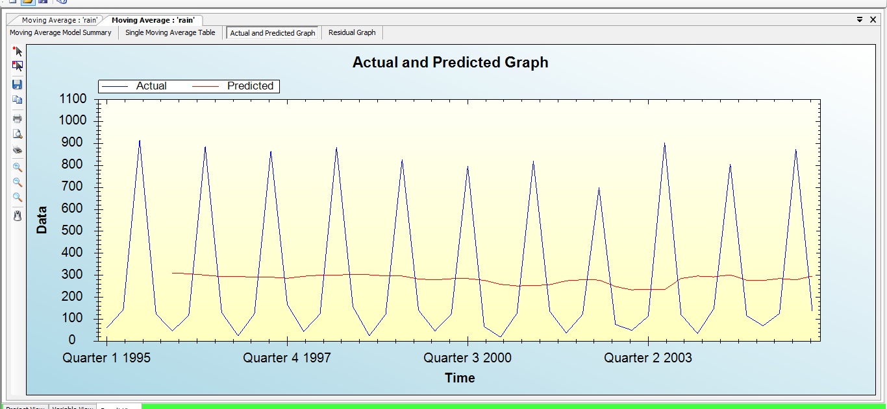

# Weighted Moving Average:

The moving average technique assigns equal weight to all previous observations



The weighted moving average technique allows for different weights to be assigned to previous observations. The Weighted Moving Average places more importance on recent data changes; therefore, the Weighted Moving Average reacts more quickly to data changes than the regular Simple Moving Average



We must determine values for k and the wi.

**EXCEL**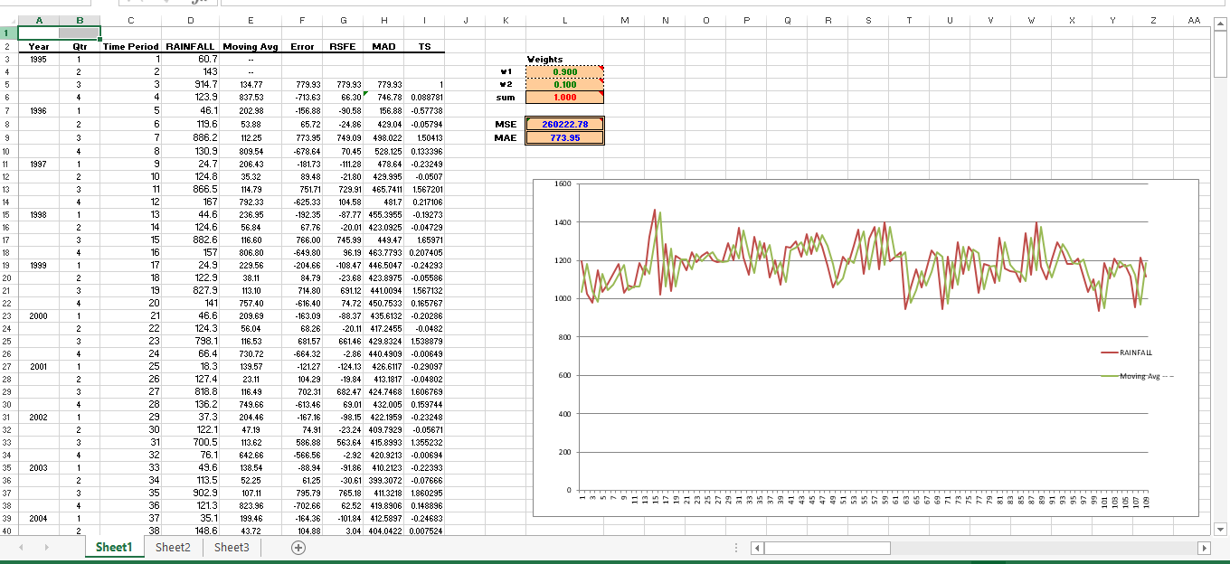

**FORECAST:**

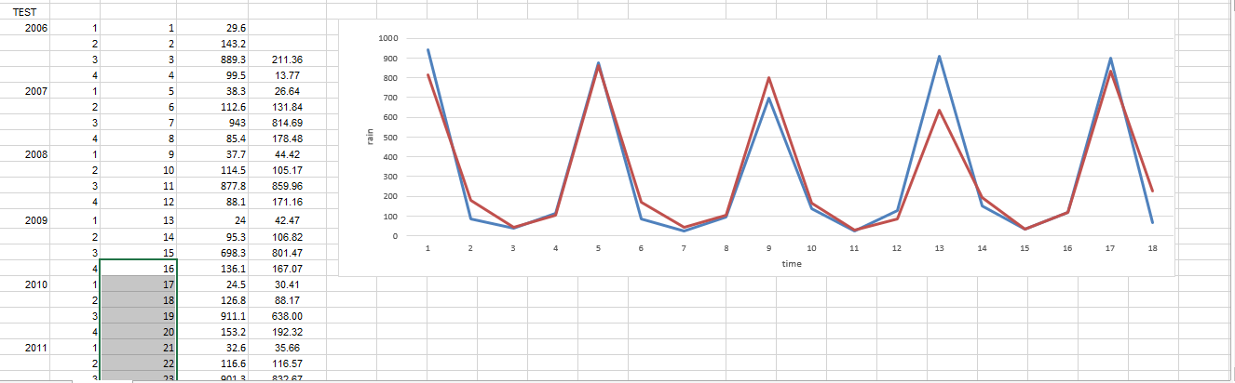

# Double moving average:





where

E*t* is the expected base level at time period *t.*

T*t* is the expected trend at time period *t.*

**EXCEL**

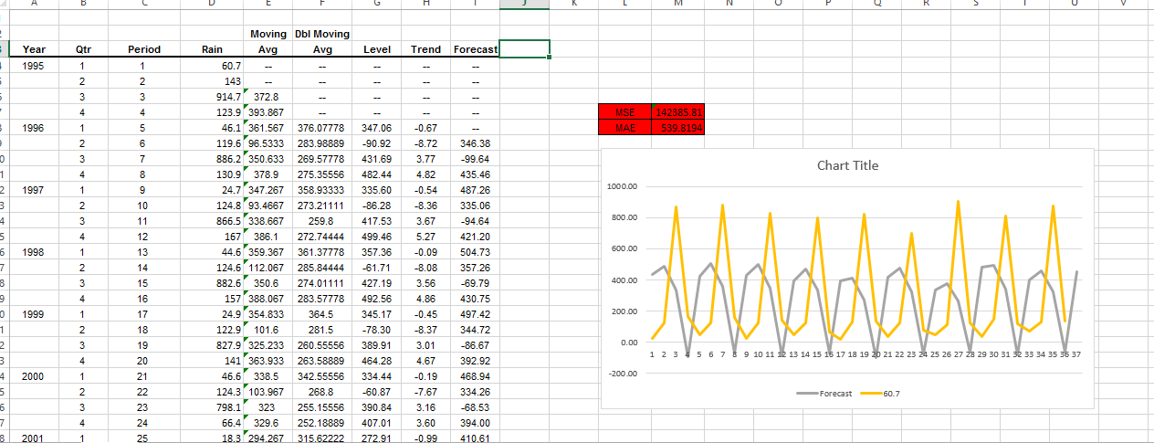

# Exponent Smoothing:

Single exponential smoothing is a forecasting technique that is useful when the historical data have no trend. In this case, the data are assumed to be relatively constant with random errors causing fluctuations. Based on the historical data an estimate of the assumed constant is determined and used for the next forecast period, t. When additional data become available the estimate is revised for the forecast period t + I. The smoothing constant is the one parameter in single exponential smoothing which can be adjusted.



It can be shown that the above equation is equivalent to:



 This method is suitable for forecasting data with no trend or seasonal pattern

**EXCEL**

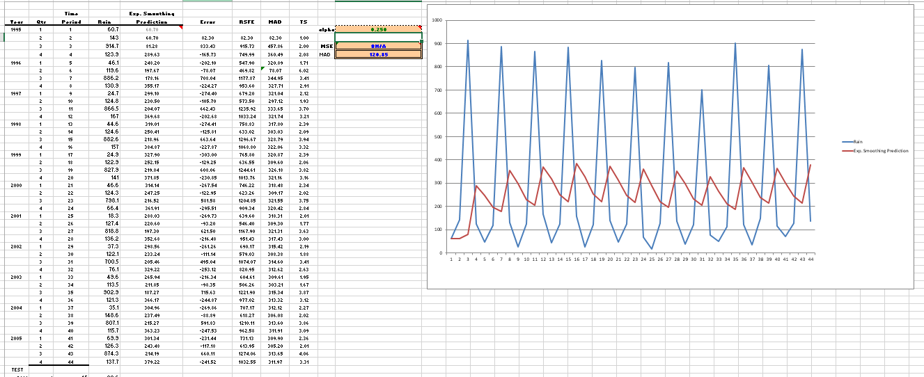

**ZAITUN**

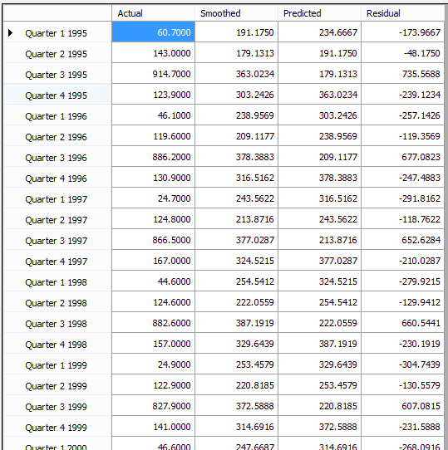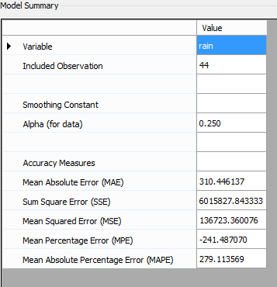

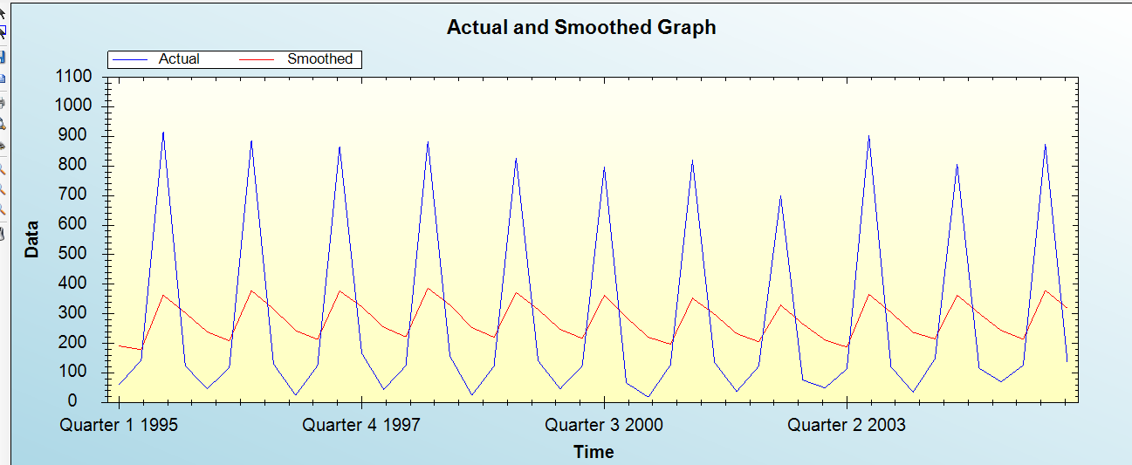

# Double Exponent Smoothing

Single Smoothing does not excel in following the data when there is a trend. This situation can be improved by the introduction of a second equation with a second constant, b, which must be chosen in conjunction with α. Like the regression forecast, the double exponential smoothing forecast is based on the assumption of a model consisting of a constant plus a linear trend.



where

E*t* = aY*t* + (1-a)(E*t*-1+ T*t*-1)

T*t* = b(E*t* -E*t*-1) + (1-b) T*t*-1



**EXCEL**

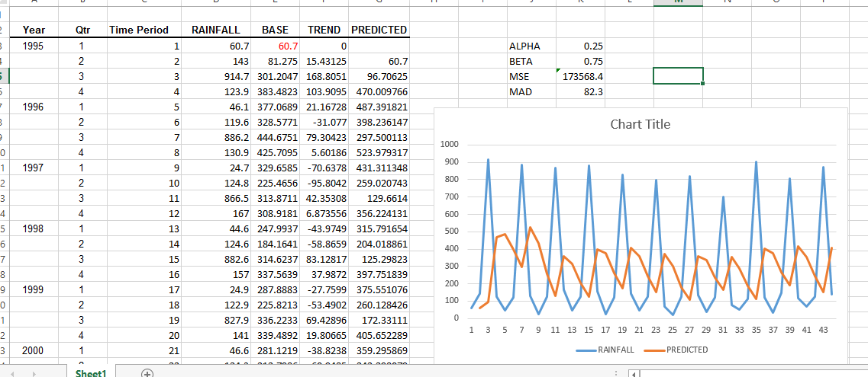

**ZIATUN**

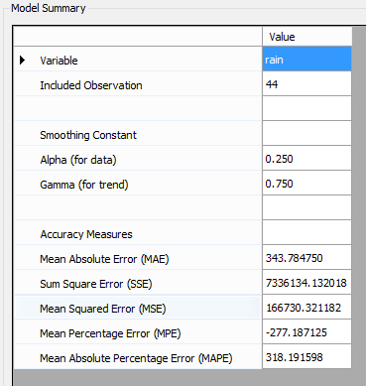

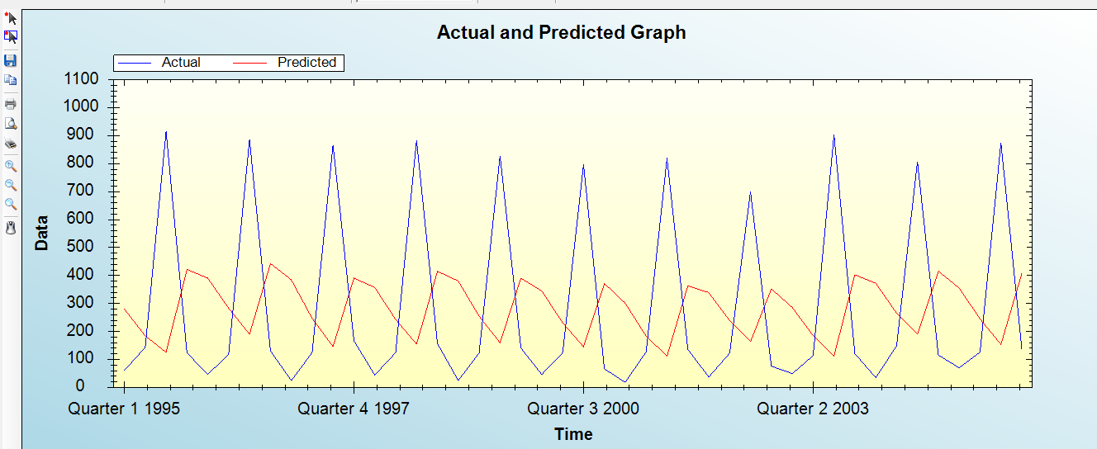8 Trend Models

Trend is the component factor of a time series most often used to make intermediate and long-range forecasts.

8.1 Linear Model

Trend analysis by default uses the linear trend model:

Yt = β0 + (β1 \* t)

In this model, β1 represents the average change from one period to the next.

**EXCEL** 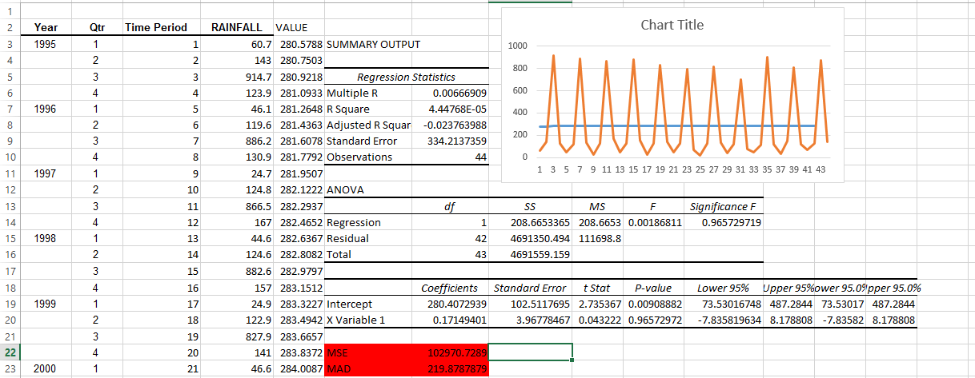

**ZAITUN**

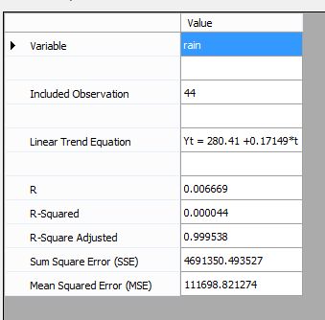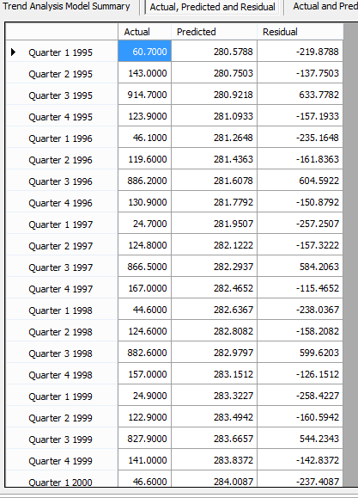

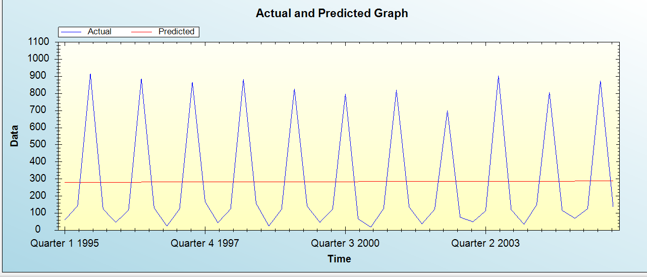

Here we see that the R2value is very low (0.0000447),indicating that only 0.0047%of the variation in revenues is explained by linear trend of the time series. A forecast of next 10 years.:

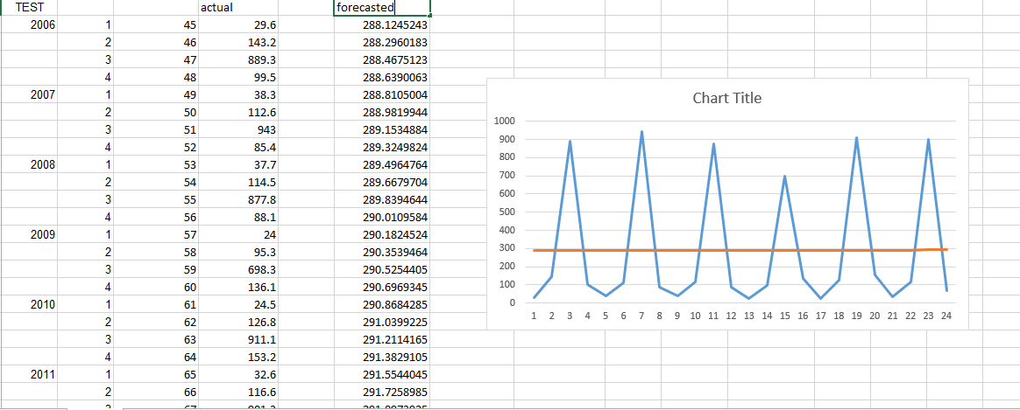

So we see that linear trend does not fit the data

* **Quadratic trend model**

The quadratic trend model, which can explain simple curvature in the data, is:

Yt = β0+ β1 \* t + (β2\* t2)

**EXCEL**

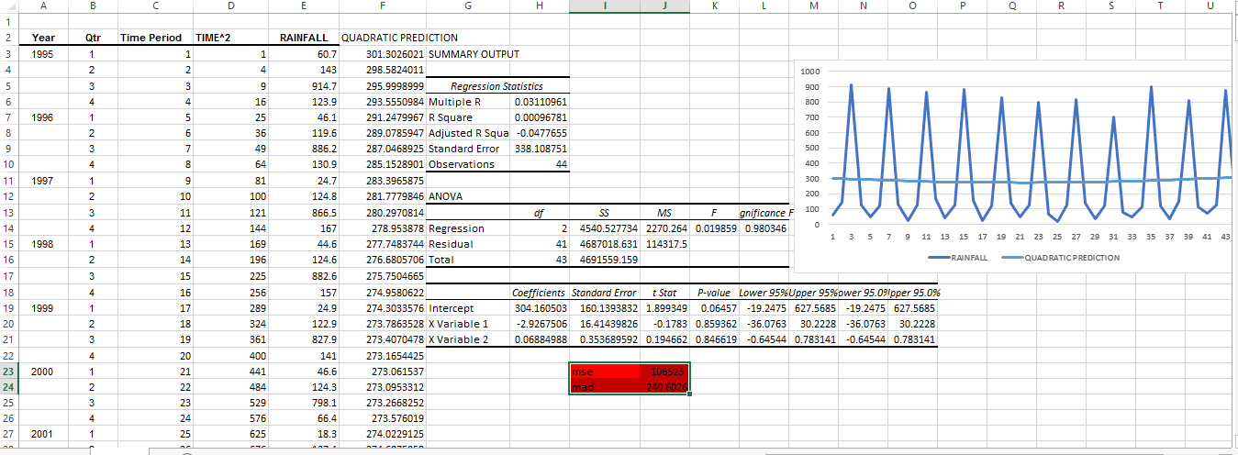

**ZAITUN**

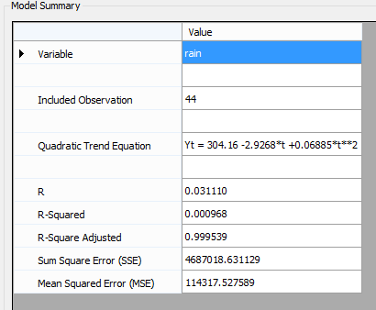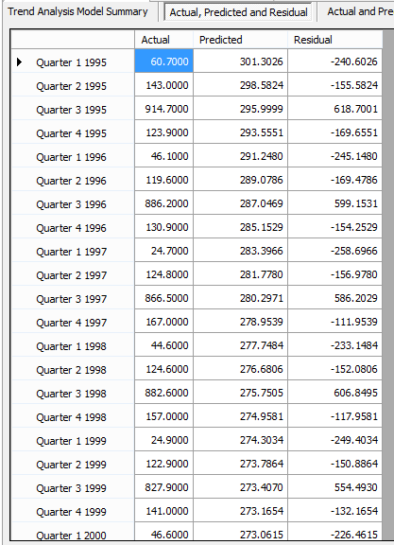

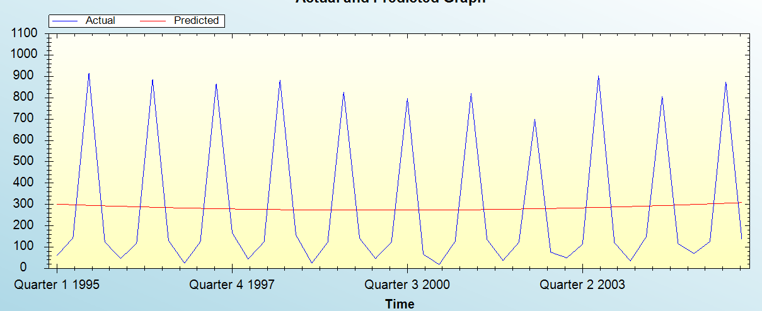

**FORECAST**

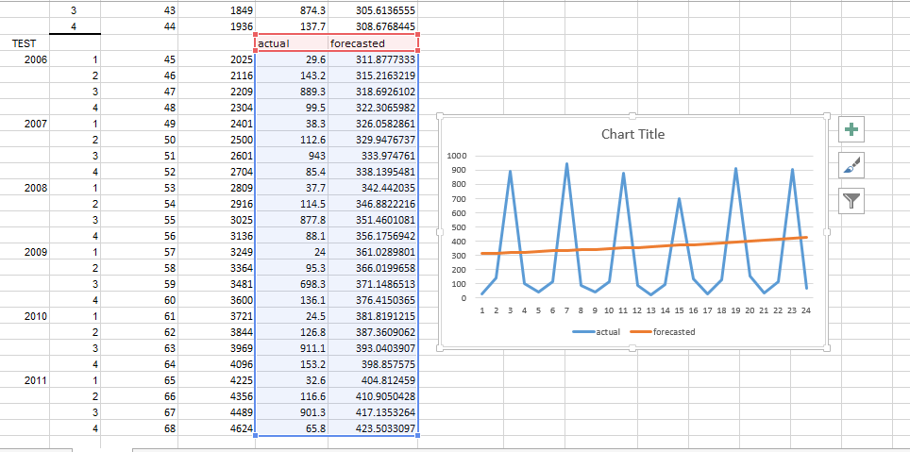

# Seasonal effects

In [statistics](http://en.wikipedia.org/wiki/Statistics), [time series](http://en.wikipedia.org/wiki/Time_series) data is data collected at regular intervals. When there are patterns that repeat over known, fixed periods of time[[1]](http://en.wikipedia.org/wiki/Seasonality#cite_note-1) within the data set it is considered to beseasonality, seasonal variation, periodic variation, or periodic fluctuations. This variation can be either regular or semi-regular.

Seasonality may be caused by various factors, such as weather, vacation, and holidays[[2]](http://en.wikipedia.org/wiki/Seasonality#cite_note-2) and usually consists of periodic, repetitive, and generally regular and predictable patterns in the levels[[3]](http://en.wikipedia.org/wiki/Seasonality#cite_note-3) of a time series. Seasonality can repeat on a weekly, monthly or quarterly basis, these periods of time are structured and occur in a length of time less than a year. Seasonal fluctuations in a time series can be contrasted with cyclical patterns. The latter occur in a period of time that extends beyond a single year, these fluctuations are usually of at least two year[[4]](http://en.wikipedia.org/wiki/Seasonality#cite_note-4) and do not repeat over fixed periods of time.

Organizations facing seasonal variations, such as ice-cream vendors, are often interested in knowing their performance relative to the normal seasonal variation. Seasonal variations in the labor market can be attributed to the entrance of school leavers into the job market; as they aim to contribute to the workforce during their vacations, or upon the completion of their schooling.

Seasonality is a regular, repeating pattern in time series data. May be additive or multiplicative in nature...





# Additive Seasonal Model



Where,







*p* represents the number of seasonal periods

**EXCEL**

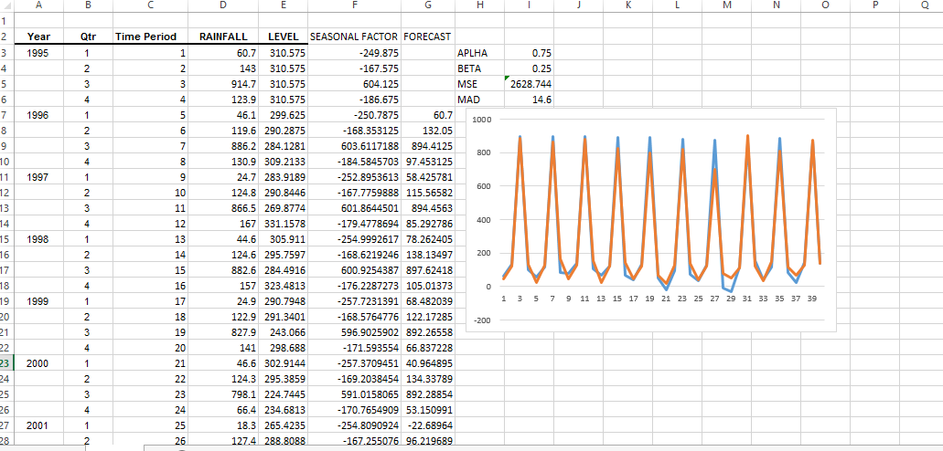

**TEST**

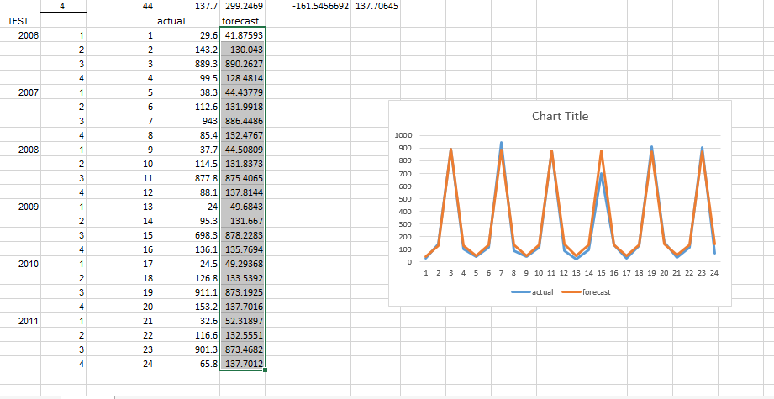

# Multiplicative Seasonal Model:



*p* represents the number of seasonal periods

where







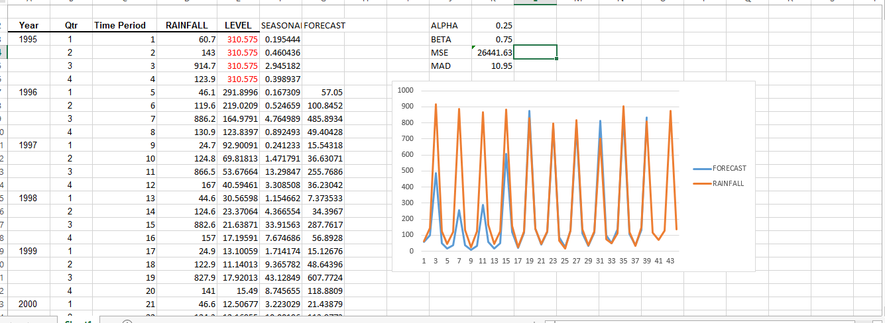

**TEST**

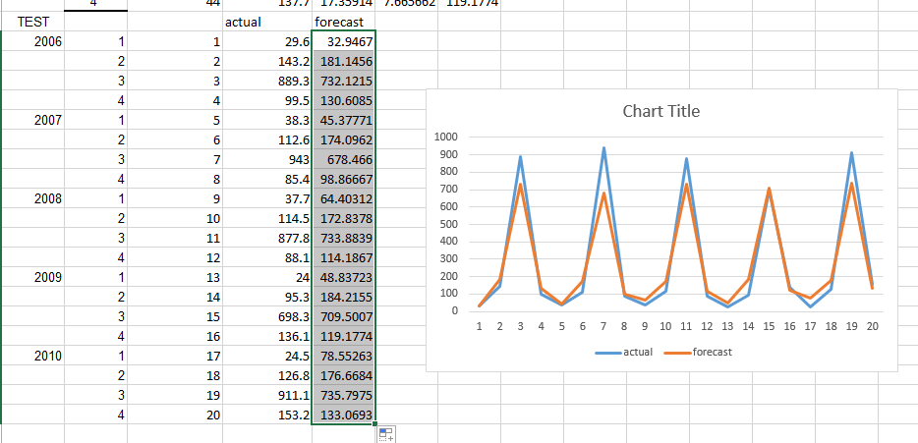

# HOLTS WINTERS Model

Holt (1957) and Winters (1960) extended Holt’s method to capture seasonality. The Holt-Winters seasonal method comprises the forecast equation and three smoothing equations — one for the level ℓ*t*, one for trend *bt*, and one for the seasonal component denoted by *st*, with smoothing parameters *α*, *β*∗ and *γ*. We use *m* to denote the period of the seasonality, i.e., the number of seasons in a year. For example, for quarterly data *m*=4, and for monthly data *m*=12.

There are two variations to this method that differ in the nature of the seasonal component. The additive method is preferred when the seasonal variations are roughly constant through the series, while the multiplicative method is preferred when the seasonal variations are changing proportional to the level of the series. With the additive method, the seasonal component is expressed in absolute terms in the scale of the observed series, and in the level equation the series is seasonally adjusted by subtracting the seasonal component. Within each year the seasonal component will add up to approximately zero. With the multiplicative method, the seasonal component is expressed in relative terms (percentages) and the series is seasonally adjusted by dividing through by the seasonal component. Within each year, the seasonal component will sum up to approximately *m*.

# 10.1 Holt-Winters additive method



where







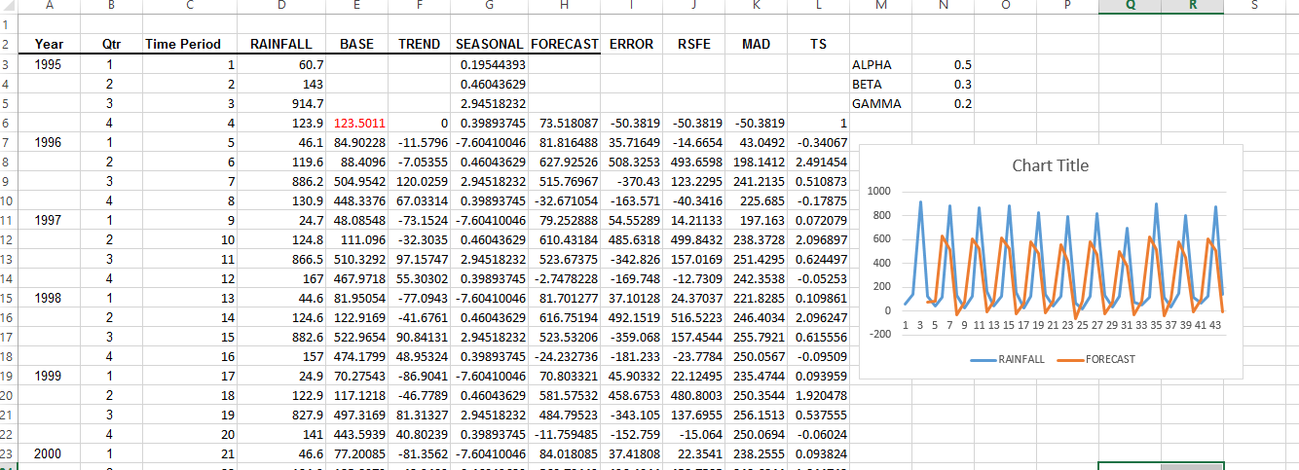

# Holt-Winters multiplicative method

The component form for the multiplicative method is:

where







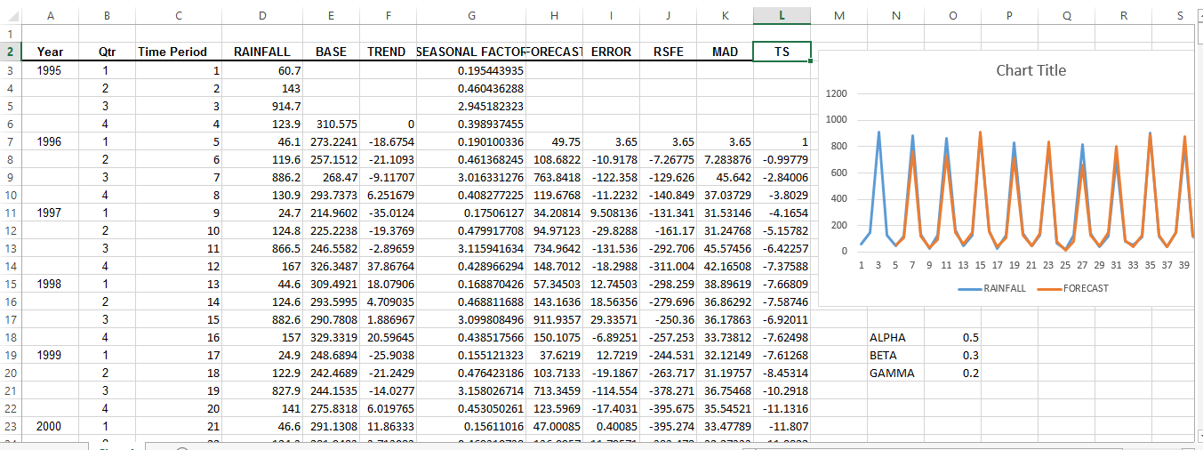

# 11. Seasonal Indices

We can compute multiplicative seasonal adjustment indices for period *p* as follows:



The final forecast for period *i* is then

**Steps:**

1,Create a trend model and calculate the estimated value ( ) for each observation in the sample.

2. For each observation, calculate the ratio of the actual value to the predicted trend value:

3. For each season, compute the average of the ratios calculated in step 2. These are the seasonal indices.

4. Multiply any forecast produced by the trend model by the appropriate seasonal index calculated in step 3.

# 12. Matlab Program For Forecasting Rainfall Using Linear Trend , Moving Average Smoothing And Seasonal Indices

Trend function to find linear trend

function [ theta1,theta2 ] = trend(a,b)

[n,m]=size(a);

a(:,1)=a(:,1)

ty=sum(a.\*b);

y=sum(b);

t=sum(a);

t2=sum(a.\*a);

theta1=((n\*ty)-(y\*t))/(n\*t2-t\*t);

theta2=(y/n)-(theta1\*t/n);

end

Function to calculate moving average

function [ ma ] = movinga( a,b,n )

[l,m]=size(a);

syms I;

sum1=0;

sum2=0;

n;

p=l-((n-1)/2);

if mod(n,2)~=0;

for i=1:l

if i<=n/2

ma(i,1)=0;

elseif i>=p

ma(i,1)=0;

else

sum1=0;

for j=round(i-((n-1)/2)):round(i+((n-1)/2));

sum1=sum1+a(j,1);

end

end

sum1;

ma(i,1)=sum1/n;

end

for u=i:(n-1)/2;

ma(u,1)=0;

end

ma

p=round(p-1);

plot(b,ma,'b--\*');

else

for i=1:l

if i<=n/2

ma(i,1)=0;

elseif i>l-(n/2)

ma(i,1)=0;

else

sum1=0;

sum2=0;

for j=round(i-((n)/2)):round(i-1+((n)/2))

sum1=sum1+a(j,1);

end

for j=round(i+1-((n)/2)):round(i+((n)/2))

sum2=sum2+a(j,1);

end

sum1=sum1/n;

sum2=sum2/n;

ma(i,1)=(sum1+sum2)/2;

end

end

end

Function to calculate the seasonal index

function [c1,c2] = season(a)

a

[l,m]=size(a);

seasonly=a(1,2:m)';

for i=2:l

seasonly=[seasonly;a(i,2:m)'];

end

[j,h]=size(seasonly);

ma=movinga(seasonly,a(:,1),m-1)

si(1:(m-1)/2,1)=0;

si(((m-1)/2)+1:j-(m-1)/2,1)=seasonly(((m-1)/2)+1:j-(m-1)/2,1)./ma(((m-1)/2)+1:j-(m-1)/2,1);

si(j-((m-1)/2)+1:j,1)=0;

si

[z,g]=size(si);

q1=0;

for i=1:m-1

q(i,1)=0;

z-(m-i);

for t=i:m-1:z

q(i,1)=q(i,1)+si(t,1);

end

end

sum(q);

corrfactor=(m-1)/sum(q);

adjq=q.\*corrfactor;

d=deseason(adjq,seasonly);

x=[1:j]';

plot(x,seasonly,'r--\*')

hold on

plot(x,d,'b--\*')

[coeff1,coeff2]=trend(x,d)

deq=coeff1.\*x+coeff2;

plot(x,deq)

syms variab

c1=coeff1;

c2=coeff2;

hold off

end

Function to deseasonalise the data

function [d] = deseason( q,t )

t;

q;

[m,n]=size(t);

[s,v]=size(q);

for i=1:s

for j=i:s:m

t(j,1);

q(i,1);

d(j,1)=t(j,1)/q(i,1);

end

end

end

A function to call all other functions

function [ output\_args ] = forecast( y,q,data)

noq=(y\*4)+q

syms deqn x

[c1,c2]=season(data)

deqn=(c1\*x)+c2

double(subs(deqn,x,noq))

end

**OUTPUT**

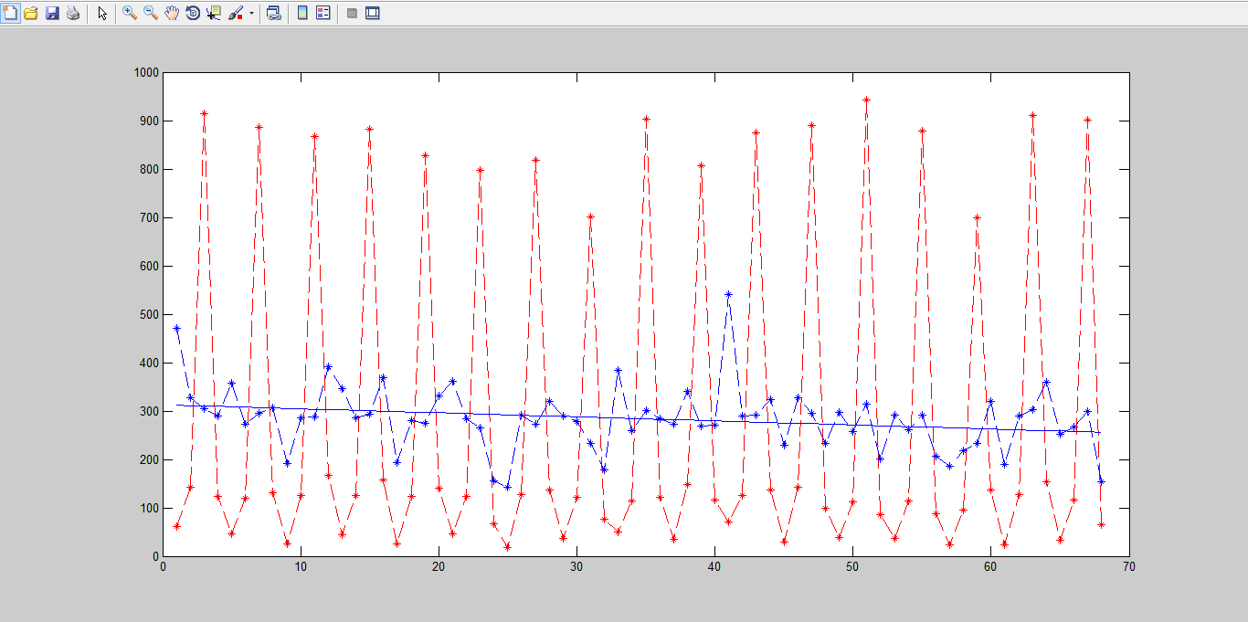

>> forecast(1,2,a)

noq =

6

ans =

307.9476

# REFERENCE

<http://www.cengage.com/resource_uploads/downloads/0840062389_347257.pdf>

<http://www.udel.edu/FREC/ilvento/BUAD820/MOD604.pdf>

<https://onlinecourses.science.psu.edu/stat510/node/70>

<http://www.dtic.mil/dtic/tr/fulltext/u2/749260.pdf>

<https://www.otexts.org/fpp/7/5>

<http://robjhyndman.com/hyndsight/cyclicts/>